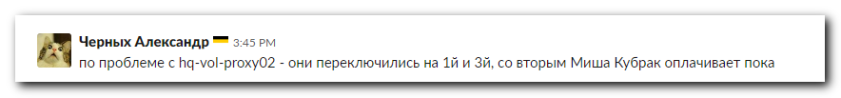

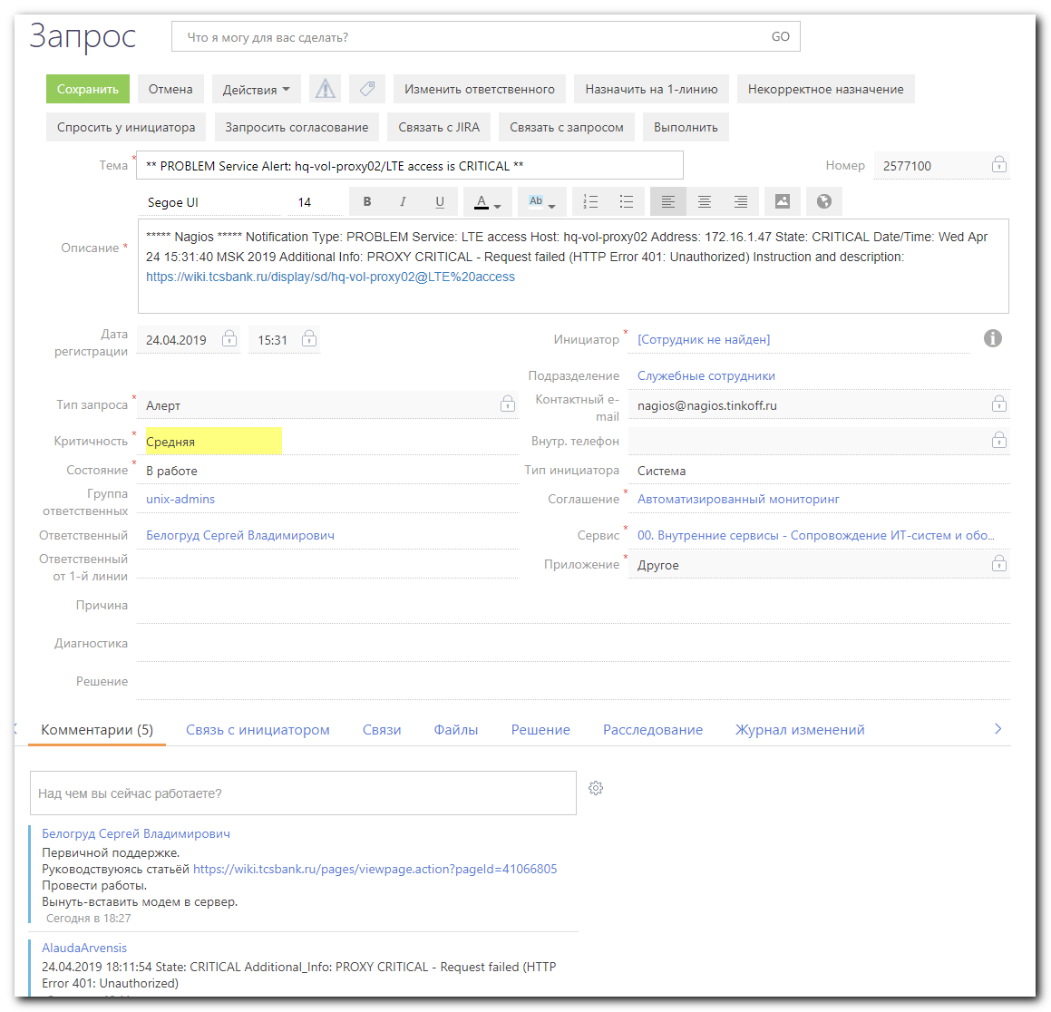

#
# Вероятно заинтересованное лицо, чей сервис использует этот модем.
# Он повысил приоритет заявки на красный.
Nurmukhamedov Denis Yuryevich
Куратор поддержки сервисов для юридических лиц, Отдел поддержки продуктов для юридических лиц.
d.nurmukhamedov@tinkoff.ru
39317
+79206613011

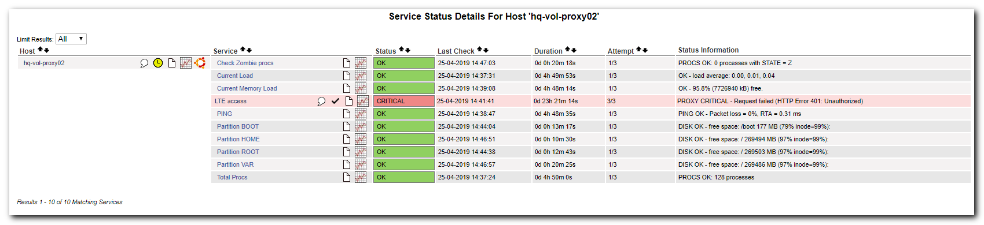

https://wiki.tcsbank.ru/pages/viewpage.action?pageId=41066805&refresh=1556119839771&focusedCommentId=387588197&refresh=1556119965905#comment-387588197

Перейти к концу метаданных
- Создал(а) Zbiranik Evgeniy Aleksandrovich, редактировал(а) Chernyh Aleksandr Vladimirovich апр 18, 2019
Переход к началу метаданных
На серверах vm-prt-dev-crl01.tcsbank.ru и vm-prt-prod-crl01.tcsbank.ru работает Crawler которому необходим выход в интернет через пул ip-адресов мобильных операторов.
Для этих целей на ПК
- hq-vol-proxy01.tcsbank.ru (172.16.1.35) - megafno - +79261158279
- hq-vol-proxy02.tcsbank.ru (172.16.1.47) - mts - +79857176150
- hq-vol-proxy03.tcsbank.ru (172.16.1.48) - beeline - +79031559376
установлены USB-модемы и работает прокси сервер Squid который предоставляет выход в интернет через модем.
ПК установлены в серверной второго этажа около турникетов в средней стойке на полу.
На ПК установлено следующее ПО:
- Ubuntu 14.04.2 LTS
- USB Модем
- Squid
В случае проблем с доступом в интернет через модем, необходимо:
- Зайти на ПК под пользователем root

- Проверить наличие интерфейса eth0 с адресом 192.168.8.100

eth0: <BROADCAST,MULTICAST,UP,LOWER_UP> mtu 1500 qdisc pfifo_fast state UNKNOWN group default qlen 1000
link/ether 0c:5b:8f:27:9a:64 brd ff:ff:ff:ff:ff:ff
inet 192.168.8.100/24 brd 192.168.8.255 scope global eth0
valid_lft forever preferred_lft forever
inet6 fe80::e5b:8fff:fe27:9a64/64 scope link
valid_lft forever preferred_lft forever

- Проверить наличие маршрута по умолчанию через usb-модем
Kernel IP routing table
Destination Gateway Genmask Flags MSS Window irtt Iface
0.0.0.0 192.168.8.1 0.0.0.0 UG 0 0 0 eth0

- Проверить статус squid
root@hq-vol-proxy02:~# service squid3 status
squid3 start/running, process 1001

Если доступа в сеть через usb-модем нет, то необходимо вынуть и снова вставить usb-модем в ПК.

Ещё данные в NetBox по этим рабочим станциям DEPO Computers:
https://netbox.tcsbank.ru/search/?q=hq-vol-proxy&obj_type=
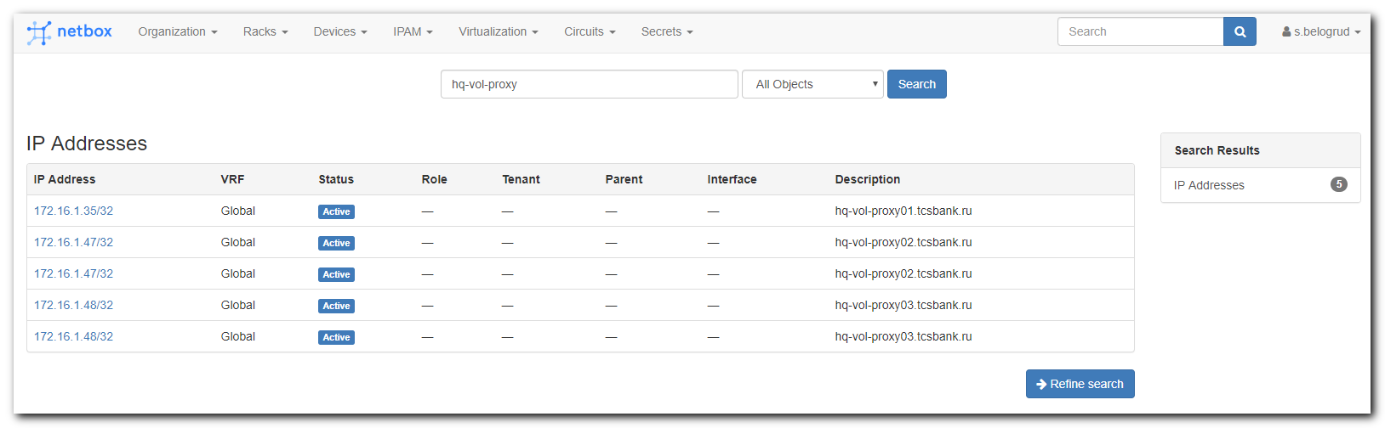

[s.belogrud@TCS4357]# ssh root@hq-vol-proxy02
root@hq-vol-proxy02's password:
Welcome to Ubuntu 14.04.2 LTS (GNU/Linux 3.16.0-30-generic x86_64)

* Documentation: https://help.ubuntu.com/

System information as of Fri Apr 19 09:35:54 MSK 2019

System load: 0.0 Processes: 123
Usage of /: 2.9% of 284.78GB Users logged in: 0
Memory usage: 4% IP address for p4p1: 172.16.1.47
Swap usage: 0% IP address for eth0: 192.168.8.100

Graph this data and manage this system at:
https://landscape.canonical.com/

283 packages can be updated.
215 updates are security updates.

New release '16.04.6 LTS' available.
Run 'do-release-upgrade' to upgrade to it.

Last login: Fri Apr 19 09:35:55 2019 from tcs5368.tcsbank.ru
root@hq-vol-proxy02:~#

root@hq-vol-proxy02:~# dmidecode -t system
# dmidecode 2.12
# SMBIOS entry point at 0x000f04c0
SMBIOS 2.7 present.

Handle 0x0001, DMI type 1, 27 bytes
System Information
Manufacturer: DEPO Computers
Product Name: To be filled by O.E.M.
Version: To be filled by O.E.M.
Serial Number: 356245-060
UUID: 03DE0294-0480-05AB-C606-BD0700080009
Wake-up Type: Power Switch
SKU Number: To be filled by O.E.M.
Family: To be filled by O.E.M.

Handle 0x0028, DMI type 12, 5 bytes
System Configuration Options
Option 1: To Be Filled By O.E.M.

Handle 0x0029, DMI type 32, 20 bytes
System Boot Information
Status: No errors detected

root@hq-vol-proxy02:~#

root@hq-vol-proxy02:~# ip -f inet addr | grep inet
inet 127.0.0.1/8 scope host lo
inet 172.16.1.47/24 brd 172.16.1.255 scope global p4p1
inet 192.168.8.100/24 brd 192.168.8.255 scope global eth0
root@hq-vol-proxy02:~#

root@hq-vol-proxy02:~# ip route | grep -e "default"
default via 192.168.8.1 dev eth0
root@hq-vol-proxy02:~#

root@hq-vol-proxy02:~# service squid3 status
squid3 start/running, process 15660
root@hq-vol-proxy02:~#

#
# Telnet is working from my work computer to hq-vol-proxy02 and port 3128.
#
support@TCS4357:~$ telnet hq-vol-proxy02 3128
Trying 172.16.1.47...
Connected to hq-vol-proxy02.tcsbank.ru.
Escape character is '^]'.
^]
telnet> quit
Connection closed.
support@TCS4357:~$

#
# To understand what is going on with access to the Internet thrue this modem, I’ve configured squit to allow connect to this proxy from my working computer.
# I’ve added my ip into allow list.

root@hq-vol-proxy02:~# vim /etc/squid3/squid.conf
...
# Example rule allowing access from your local networks.
# Adapt to list your (internal) IP networks from where browsing
# should be allowed
#acl localnet src 10.0.0.0/8 # RFC1918 possible internal network
#acl localnet src 172.16.0.0/12 # RFC1918 possible internal network
#acl localnet src 192.168.0.0/16 # RFC1918 possible internal network
#acl localnet src fc00::/7 # RFC 4193 local private network range
#acl localnet src fe80::/10 # RFC 4291 link-local (directly plugged) machines
acl allowedhosts src 172.27.78.4 #tcs7629
acl allowedhosts src 172.27.78.5 #tcs8254
acl allowedhosts src 172.16.28.74 #tcs4357
acl allowedhosts src 10.218.1.25 #vm-prt-prod-crl01
acl allowedhosts src 10.218.13.58 #vm-prt-dev-crl01
acl allowedhosts src 172.16.28.0/24 #admins
acl allowedhosts src 172.16.1.6 #vm-vol-nag-dev
acl allowedhosts src 172.16.1.11 #nag2
acl allowedhosts src 172.16.1.115 #nag-prep
acl allowedhosts src 172.16.1.117 #nag-tst
acl allowedhosts src 10.217.11.12 #ds-pr-ig01
acl allowedhosts src 10.217.11.19 #ds-pr-ig02
acl allowedhosts src 10.217.11.21 #ds-pr-ig03
acl allowedhosts src 10.217.10.12 #m1-pr-ig01
acl allowedhosts src 10.217.10.19 #m1-pr-ig02
acl allowedhosts src 10.217.10.21 #m1-pr-ig03
acl allowedhosts src 10.217.13.35 #vm-pr-ig01t
acl allowedhosts src 10.216.40.167 #vm-cashoff01p

acl SSL_ports port 443
acl Safe_ports port 80 # http
acl Safe_ports port 21 # ftp
acl Safe_ports port 443 # https
acl Safe_ports port 70 # gopher
acl Safe_ports port 210 # wais
acl Safe_ports port 1025-65535 # unregistered ports
acl Safe_ports port 280 # http-mgmt
acl Safe_ports port 488 # gss-http
acl Safe_ports port 591 # filemaker
acl Safe_ports port 777 # multiling http
acl CONNECT method CONNECT
...

root@hq-vol-proxy02:~# service squid3 reload

#
# Then I’ve configured firefox on my VirtualBox host to use squid, located on hq-vol-proxy02 as a proxy.
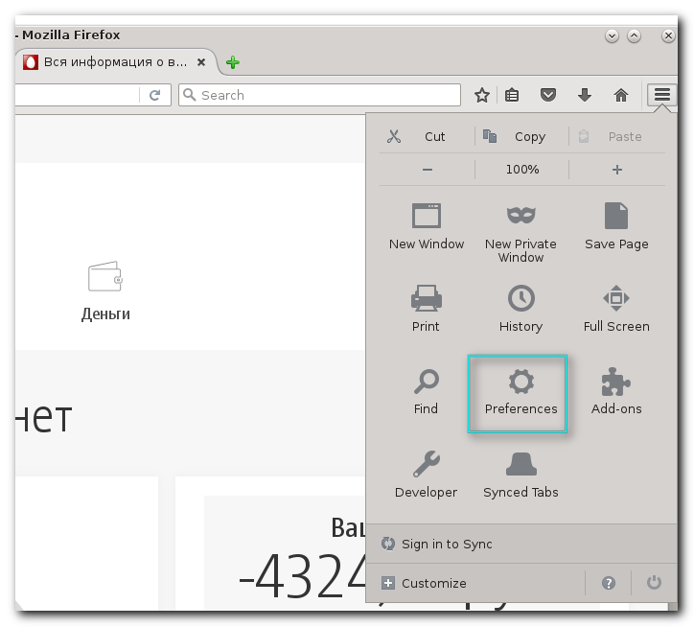
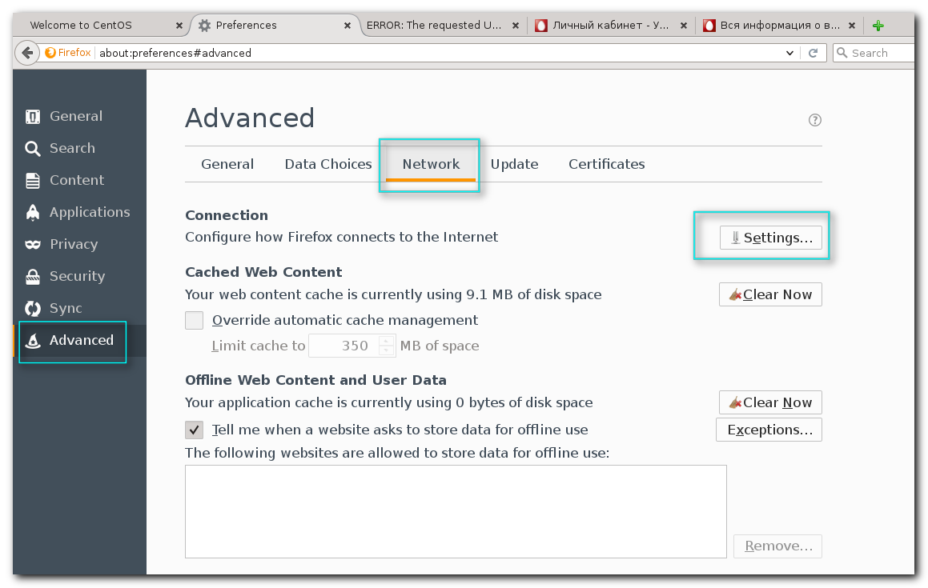
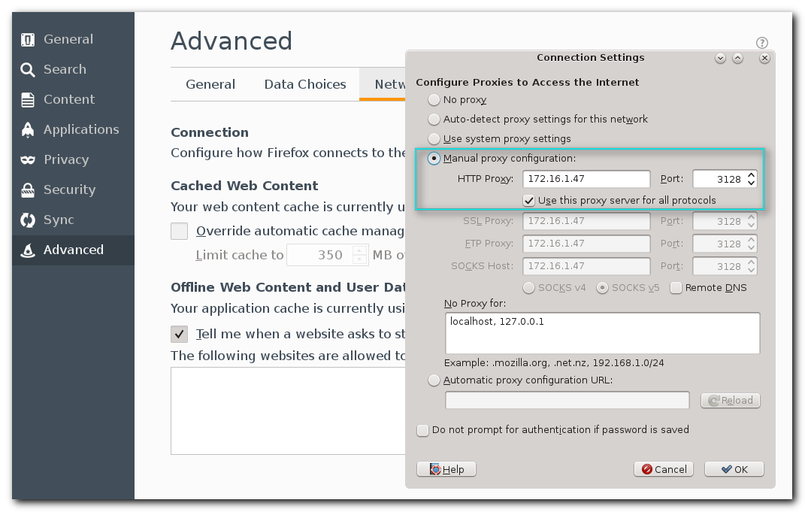

#
# I’ve tried to open ya.ru page, because it tested from nagios.
#
[root@vm-vol-nag4-tst objects]# /usr/local/nagios/libexec/check_http_proxy --proxy="172.16.1.47:3128" --url="http://ya.ru"
PROXY CRITICAL - Request failed (HTTP Error 401: Unauthorized)
[root@vm-vol-nag4-tst objects]#

# But, that was not helpful.
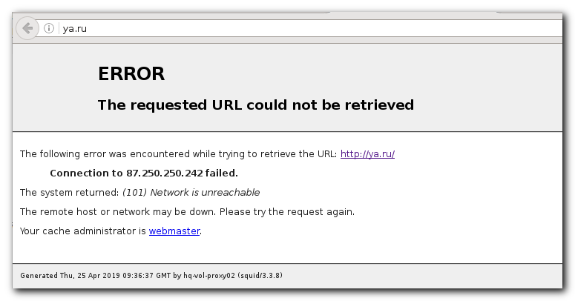

#
# Then, I’ve attempted to open other address: yandex.ru.
# And then I was transferred to MTS page.
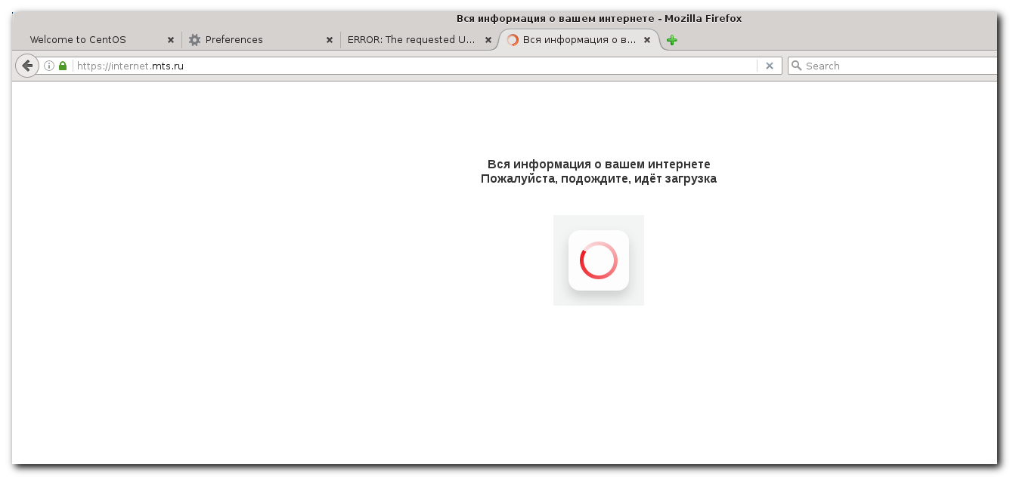
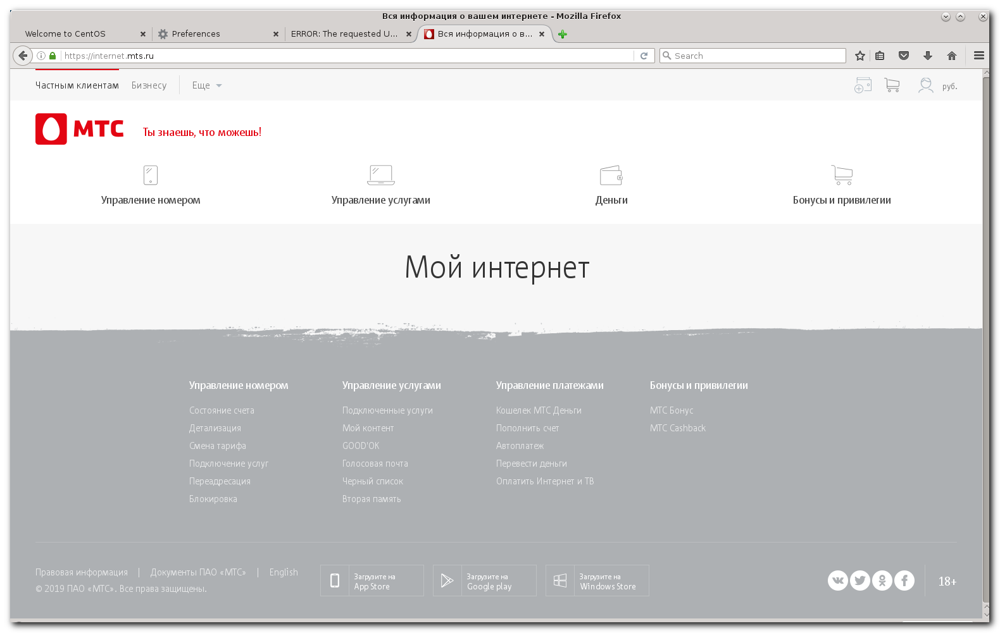

#
# And here I’ve seen debt 4324,21 rub.
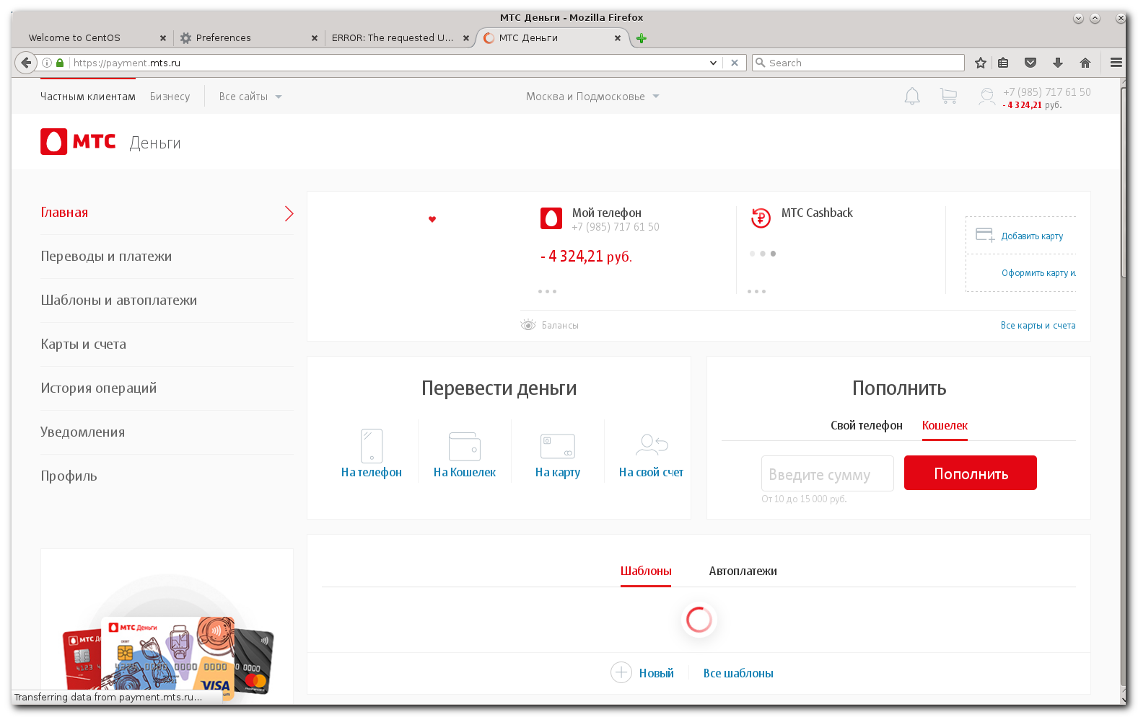
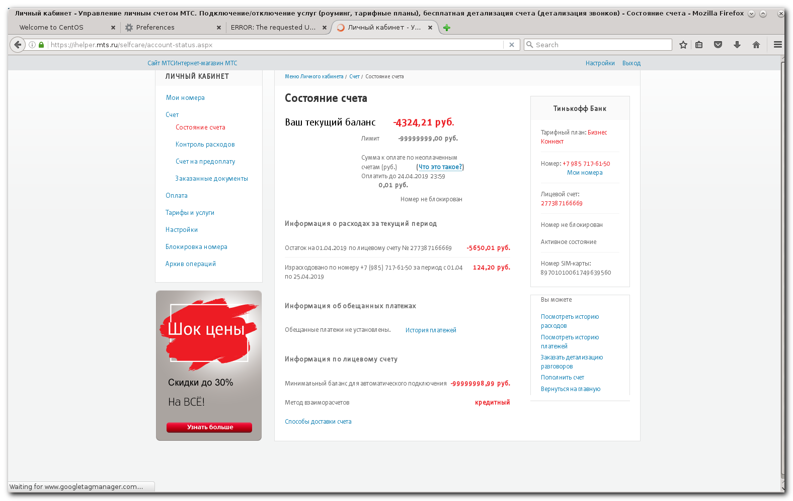

# And here: 0 MB available traffic.
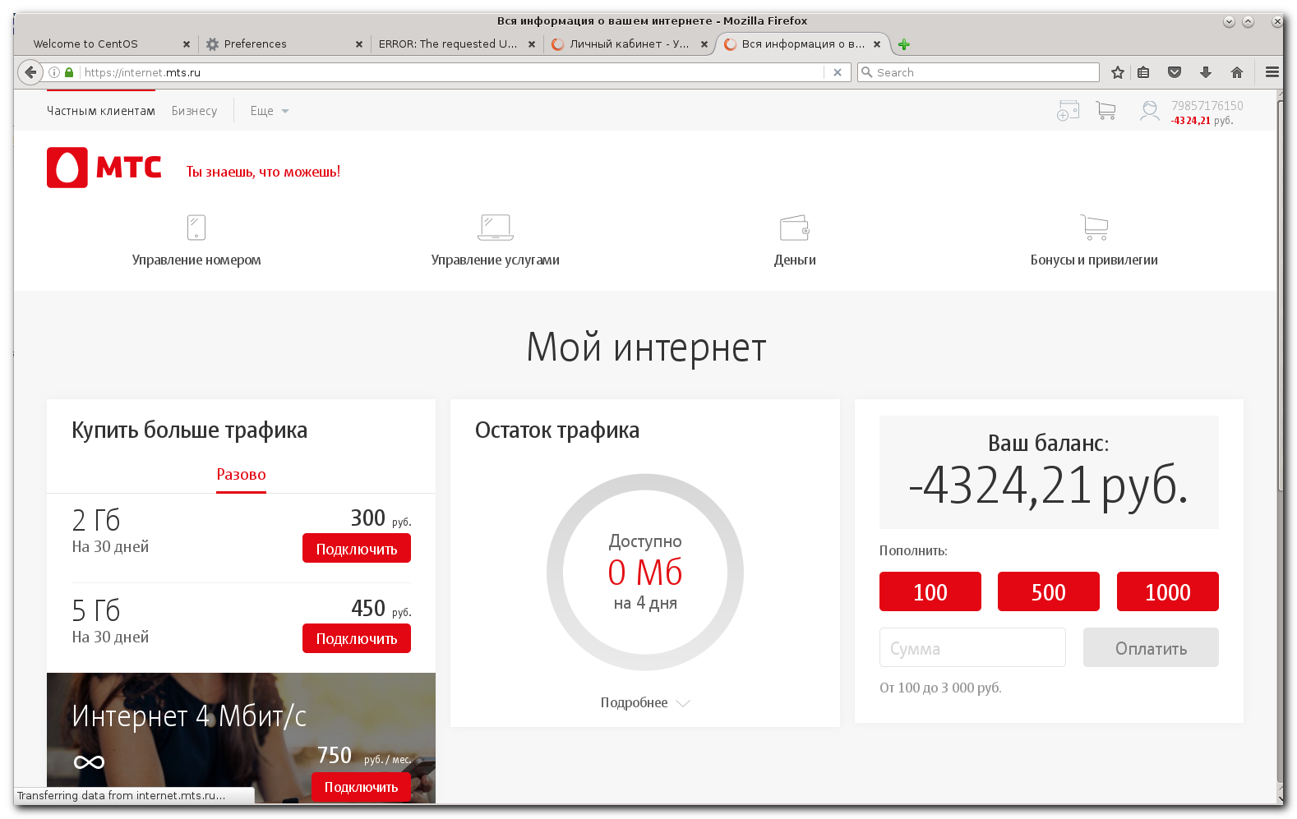

#
# 20190425
# Кубрак Михаил платит за пакет доступа к Интернет по этому модему.
# До сего дня было 6ГБ днём и безлимит ночью. С сегодняшнего дня будет 15ГБ днём и безлимит ночью. Это где-то в тарифном плане написано и # Михаил это у себя посмотрел. Кубрак предположил, что что-то выжрало весь трафик и интернет закончился.
# Кубрак сказал, что нужно смотреть не на задолженность а на “Остаток трафика” - оно же Доступно МБ. Если там ноль - то интернета нет…
#

................................................................................

[root@vm-vol-nag4-tst objects]# vim servers/of-vol-linux/hq-vol-proxy02.cfg
define host{
use linux-server
host_name hq-vol-proxy02
address 172.16.1.47
icon_image ubuntu.png
}
...
define service{
use generic-service
host_name hq-vol-proxy02
service_description LTE access
# contacts d.a.martyanov_sms
check_command check_squid_proxy!http://ya.ru
}
...

[root@vm-vol-nag4-tst objects]# vim commands.cfg
...
##Check crawler proxy
define command{
command_name check_squid_proxy
command_line $USER1$/check_http_proxy --proxy=$HOSTADDRESS$:3128 --url="$ARG1$"
}
##Check crawler proxy end
...

................................................................................

[root@vm-vol-nag4-tst objects]# /usr/local/nagios/libexec/check_http_proxy --proxy="172.16.1.47:3128" --url="http://ya.ru"
PROXY CRITICAL - Request failed (HTTP Error 401: Unauthorized)
[root@vm-vol-nag4-tst objects]#

[root@vm-vol-nag4-tst objects]# /usr/local/nagios/libexec/check_http_proxy --proxy="172.16.1.47:3128" --url="http://ya.ru"
PROXY CRITICAL - Request failed (HTTP Error 401: Unauthorized)
[root@vm-vol-nag4-tst objects]#

root@hq-vol-proxy02:~# uptime
11:41:09 up 1:38, 3 users, load average: 0.08, 0.03, 0.05
root@hq-vol-proxy02:~#
root@hq-vol-proxy02:~# last reboot -a -d -F -x -n 10
reboot system boot Thu Apr 25 10:02:35 2019 - Thu Apr 25 11:42:18 2019 (01:39) 0.0.0.0
reboot system boot Wed Apr 24 20:35:46 2019 - Thu Apr 25 09:48:47 2019 (13:13) 0.0.0.0

wtmp begins Mon Apr 1 13:37:17 2019
root@hq-vol-proxy02:~#

#
# Date on server is differ from current on 7 minutes.
#
root@hq-vol-proxy02:~# date
Thu Apr 25 11:44:16 MSK 2019
root@hq-vol-proxy02:~# ntpq -nc pe
The program 'ntpq' is currently not installed. You can install it by typing:
apt-get install ntp
root@hq-vol-proxy02:~#

................................................................................

root@hq-vol-proxy02:~# apt-get update
Ign http://security.ubuntu.com trusty-security InRelease
Ign http://security.ubuntu.com trusty-security Release.gpg
Ign http://security.ubuntu.com trusty-security Release
Err http://security.ubuntu.com trusty-security/universe amd64 Packages

Err http://security.ubuntu.com trusty-security/universe amd64 Packages

Err http://security.ubuntu.com trusty-security/universe amd64 Packages

Err http://security.ubuntu.com trusty-security/universe amd64 Packages
Undetermined Error
Err http://repo-linux.tcsbank.ru trusty InRelease

Err http://repo-linux.tcsbank.ru trusty Release.gpg
Unable to connect to repo-linux.tcsbank.ru:http:
Reading package lists... Done
W: Failed to fetch http://repo-linux.tcsbank.ru/puppetlabs/apt/dists/trusty/InRelease

W: Failed to fetch http://security.ubuntu.com/ubuntu/dists/trusty-security/universe/binary-amd64/Packages Undetermined Error

W: Failed to fetch http://repo-linux.tcsbank.ru/puppetlabs/apt/dists/trusty/Release.gpg Unable to connect to repo-linux.tcsbank.ru:http:

W: Some index files failed to download. They have been ignored, or old ones used instead.
root@hq-vol-proxy02:~# cat /etc/os-release
NAME="Ubuntu"
VERSION="14.04.2 LTS, Trusty Tahr"
ID=ubuntu
ID_LIKE=debian
PRETTY_NAME="Ubuntu 14.04.2 LTS"
VERSION_ID="14.04"
HOME_URL="http://www.ubuntu.com/"
SUPPORT_URL="http://help.ubuntu.com/"
BUG_REPORT_URL="http://bugs.launchpad.net/ubuntu/"
root@hq-vol-proxy02:~# curl http://repo-linux | head
% Total % Received % Xferd Average Speed Time Time Time Current
Dload Upload Total Spent Left Speed
0 0 0 0 0 0 0 0 --:--:-- 0:00:07 --:--:-- 0^C
root@hq-vol-proxy02:~# telnet repo-linux.tcsbank.ru 80
Trying 10.216.42.6...
^C
root@hq-vol-proxy02:~# host repo-linux.tcsbank.ru
repo-linux.tcsbank.ru is an alias for ds-repo01.tcsbank.ru.
ds-repo01.tcsbank.ru has address 10.216.42.6
root@hq-vol-proxy02:~#

................................................................................

root@hq-vol-proxy02:~# lspci
00:00.0 Host bridge: Intel Corporation Xeon E3-1200 v2/3rd Gen Core processor DRAM Controller (rev 09)
00:02.0 VGA compatible controller: Intel Corporation Xeon E3-1200 v2/3rd Gen Core processor Graphics Controller (rev 09)
00:16.0 Communication controller: Intel Corporation 6 Series/C200 Series Chipset Family MEI Controller #1 (rev 04)
00:1a.0 USB controller: Intel Corporation 6 Series/C200 Series Chipset Family USB Enhanced Host Controller #2 (rev 05)
00:1b.0 Audio device: Intel Corporation 6 Series/C200 Series Chipset Family High Definition Audio Controller (rev 05)
00:1c.0 PCI bridge: Intel Corporation 6 Series/C200 Series Chipset Family PCI Express Root Port 1 (rev b5)
00:1c.4 PCI bridge: Intel Corporation 6 Series/C200 Series Chipset Family PCI Express Root Port 5 (rev b5)
00:1c.5 PCI bridge: Intel Corporation 82801 PCI Bridge (rev b5)
00:1d.0 USB controller: Intel Corporation 6 Series/C200 Series Chipset Family USB Enhanced Host Controller #1 (rev 05)
00:1f.0 ISA bridge: Intel Corporation H61 Express Chipset Family LPC Controller (rev 05)
00:1f.2 SATA controller: Intel Corporation 6 Series/C200 Series Chipset Family SATA AHCI Controller (rev 05)
00:1f.3 SMBus: Intel Corporation 6 Series/C200 Series Chipset Family SMBus Controller (rev 05)
02:00.0 Ethernet controller: Realtek Semiconductor Co., Ltd. RTL8111/8168/8411 PCI Express Gigabit Ethernet Controller (rev 06)
03:00.0 PCI bridge: Intel Corporation 82801 PCI Bridge (rev 41)
root@hq-vol-proxy02:~# lsusb
Bus 002 Device 004: ID 12d1:1566 Huawei Technologies Co., Ltd.
Bus 002 Device 002: ID 8087:0024 Intel Corp. Integrated Rate Matching Hub
Bus 002 Device 001: ID 1d6b:0002 Linux Foundation 2.0 root hub
Bus 001 Device 002: ID 8087:0024 Intel Corp. Integrated Rate Matching Hub
Bus 001 Device 001: ID 1d6b:0002 Linux Foundation 2.0 root hub
root@hq-vol-proxy02:~#

root@hq-vol-proxy02:~# lsusb -s 004
Bus 002 Device 004: ID 12d1:1566 Huawei Technologies Co., Ltd.
root@hq-vol-proxy02:~# lsusb -s 004 -v

Bus 002 Device 004: ID 12d1:1566 Huawei Technologies Co., Ltd.
Device Descriptor:
bLength 18
bDescriptorType 1
bcdUSB 2.10
bDeviceClass 0 (Defined at Interface level)
bDeviceSubClass 0
bDeviceProtocol 255
bMaxPacketSize0 64
idVendor 0x12d1 Huawei Technologies Co., Ltd.
idProduct 0x1566
bcdDevice 1.02
iManufacturer 1 HUAWEI_MOBILE
iProduct 2 HUAWEI_MOBILE
iSerial 0
bNumConfigurations 1
Configuration Descriptor:
bLength 9
bDescriptorType 2
wTotalLength 350
bNumInterfaces 9
bConfigurationValue 1
iConfiguration 0
bmAttributes 0xc0
Self Powered
MaxPower 2mA
Interface Association:
bLength 8
bDescriptorType 11
bFirstInterface 0
bInterfaceCount 2
bFunctionClass 224 Wireless
bFunctionSubClass 1 Radio Frequency
bFunctionProtocol 3 RNDIS
iFunction 7 RNDIS
...

................................................................................

root@hq-vol-proxy02:~# ip -f inet addr
1: lo: <LOOPBACK,UP,LOWER_UP> mtu 65536 qdisc noqueue state UNKNOWN group default
inet 127.0.0.1/8 scope host lo
valid_lft forever preferred_lft forever
2: p4p1: <BROADCAST,MULTICAST,UP,LOWER_UP> mtu 1500 qdisc pfifo_fast state UP group default qlen 1000
inet 172.16.1.47/24 brd 172.16.1.255 scope global p4p1
valid_lft forever preferred_lft forever
3: eth0: <BROADCAST,MULTICAST,UP,LOWER_UP> mtu 1500 qdisc pfifo_fast state UNKNOWN group default qlen 1000
inet 192.168.8.100/24 brd 192.168.8.255 scope global eth0
valid_lft forever preferred_lft forever
root@hq-vol-proxy02:~#
root@hq-vol-proxy02:~# ip route
default via 192.168.8.1 dev eth0
10.216.40.0/24 via 172.16.1.254 dev p4p1
10.216.41.36 via 172.16.1.254 dev p4p1
10.216.98.0/24 via 172.16.1.254 dev p4p1
10.217.0.0/16 via 172.16.1.254 dev p4p1
10.218.1.0/24 via 172.16.1.254 dev p4p1
10.218.6.0/24 via 172.16.1.254 dev p4p1
10.218.13.0/24 via 172.16.1.254 dev p4p1
10.218.65.0/24 via 172.16.1.254 dev p4p1
172.16.0.0/16 via 172.16.1.254 dev p4p1
172.16.1.0/24 dev p4p1 proto kernel scope link src 172.16.1.47
172.16.10.0/24 via 172.16.1.254 dev p4p1
172.16.28.0/24 via 172.16.1.254 dev p4p1
192.168.8.0/24 dev eth0 proto kernel scope link src 192.168.8.100
root@hq-vol-proxy02:~#

................................................................................

root@hq-vol-proxy02:~# less /var/log/squid3/access.log
...
1556182756.254 169 172.16.1.11 TCP_MISS/302 320 GET http://ya.ru/ - HIER_DIRECT/87.250.250.242 text/html
1556182756.347 91 172.16.1.11 TCP_MISS/302 288 GET http://internet.mts.ru/? - HIER_DIRECT/212.188.8.51 -
1556182764.411 227 172.16.1.11 TCP_MISS_ABORTED/401 2356 GET http://login.mts.ru/amserver/UI/Login? - HIER_DIRECT/194.54.148.102 text/html
...

support@TCS4357:~$ host 172.16.1.117
117.1.16.172.in-addr.arpa domain name pointer vm-vol-nag01t.tcsbank.ru.
117.1.16.172.in-addr.arpa domain name pointer nag-tst.tcsbank.ru.
support@TCS4357:~$ host 172.16.1.11
11.1.16.172.in-addr.arpa domain name pointer nag-prod.tcsbank.ru.
11.1.16.172.in-addr.arpa domain name pointer nagios.tcsbank.ru.
11.1.16.172.in-addr.arpa domain name pointer nag2.tcsbank.ru.
support@TCS4357:~$

................................................................................

root@hq-vol-proxy02:~# less /var/log/squid3/access.log
...
1556184997.016 82 172.16.28.74 TCP_MISS/503 3787 GET http://ya.ru/ - HIER_DIRECT/87.250.250.242 text/html
1556184997.101 54 172.16.28.74 TCP_MISS/503 3893 GET http://www.squid-cache.org/Artwork/SN.png - HIER_DIRECT/216.92.2.155 text/html
1556184997.386 6 172.16.28.74 TCP_MISS/503 3788 GET http://ya.ru/favicon.ico - HIER_DIRECT/87.250.250.242 text/html
1556184997.397 6 172.16.28.74 TCP_MISS/503 3820 GET http://ya.ru/favicon.ico - HIER_DIRECT/87.250.250.242 text/html
...

................................................................................

#
# Here is how looks in log, when I opened address:
# http://internet.mts.ru
#
root@hq-vol-proxy02:~# less /var/log/squid3/access.log
...
1556185317.440 225 172.16.28.74 TCP_MISS/302 244 GET http://dengi.mts.ru/ - HIER_DIRECT/212.188.8.51 -
1556185317.721 117 172.16.28.74 TCP_MISS/302 364 POST http://status.thawte.com/ - HIER_DIRECT/93.184.220.29 text/html
1556185317.830 104 172.16.28.74 TCP_MISS/302 293 GET http://internet.mts.ru/? - HIER_DIRECT/212.188.8.51 -
1556185319.110 199 172.16.28.74 TCP_MISS/401 3080 GET http://login.mts.ru/amserver/UI/Login? - HIER_DIRECT/194.54.148.102 text/html
1556185319.551 155 172.16.28.74 TCP_MISS/302 364 POST http://ocsp.digicert.com/ - HIER_DIRECT/93.184.220.29 text/html
1556185319.612 59 172.16.28.74 TCP_MISS/302 293 GET http://internet.mts.ru/? - HIER_DIRECT/212.188.8.51 -
1556185320.651 875 172.16.28.74 TCP_MISS/401 3080 GET http://login.mts.ru/amserver/UI/Login? - HIER_DIRECT/194.54.148.102 text/html
1556185320.798 142 172.16.28.74 TCP_MISS/302 364 POST http://status.thawte.com/ - HIER_DIRECT/93.184.220.29 text/html
1556185320.880 40 172.16.28.74 TCP_MISS/302 293 GET http://internet.mts.ru/? - HIER_DIRECT/212.188.8.51 -
1556185321.738 120 172.16.28.74 TCP_MISS/401 3080 GET http://login.mts.ru/amserver/UI/Login? - HIER_DIRECT/194.54.148.102 text/html
1556185325.043 30107 10.216.40.167 TCP_MISS/200 0 CONNECT sbi.sberbank.ru:9443 - HIER_DIRECT/194.54.14.136 -
1556185326.442 160 172.16.28.74 TCP_MISS/302 364 POST http://status.thawte.com/ - HIER_DIRECT/93.184.220.29 text/html
1556185327.070 49 172.16.28.74 TCP_MISS/302 293 GET http://internet.mts.ru/? - HIER_DIRECT/212.188.8.51 -
1556185328.066 10043 172.16.28.74 TCP_MISS/200 16176 CONNECT login.mts.ru:443 - HIER_DIRECT/194.54.148.102 -
1556185328.496 428 172.16.28.74 TCP_MISS/200 2760 CONNECT staticpayment.ssl.mts.ru:443 - HIER_DIRECT/213.87.44.98 -
1556185328.497 423 172.16.28.74 TCP_MISS/200 1380 CONNECT staticpayment.ssl.mts.ru:443 - HIER_DIRECT/213.87.44.98 -
1556185328.501 2570 172.16.28.74 TCP_MISS/200 0 CONNECT www.google-analytics.com:443 - HIER_DIRECT/64.233.162.113 -
1556185328.502 2594 172.16.28.74 TCP_MISS/200 0 CONNECT mc.yandex.ru:443 - HIER_DIRECT/87.250.250.119 -
1556185328.503 2240 172.16.28.74 TCP_MISS/200 19138 CONNECT payment.mts.ru:443 - HIER_DIRECT/194.54.148.182 -
1556185328.506 426 172.16.28.74 TCP_MISS/200 3925 CONNECT staticpayment.ssl.mts.ru:443 - HIER_DIRECT/213.87.44.98 -
1556185328.509 2656 172.16.28.74 TCP_MISS/200 12258 CONNECT staticpayment.ssl.mts.ru:443 - HIER_DIRECT/213.87.44.98 -
1556185328.510 6505 172.16.28.74 TCP_MISS/200 371298 CONNECT payment.mts.ru:443 - HIER_DIRECT/194.54.148.182 -
1556185328.511 6629 172.16.28.74 TCP_MISS/200 272207 CONNECT payment.mts.ru:443 - HIER_DIRECT/194.54.148.182 -
1556185328.511 9333 172.16.28.74 TCP_MISS/200 135078 CONNECT payment.mts.ru:443 - HIER_DIRECT/194.54.148.182 -
1556185328.518 441 172.16.28.74 TCP_MISS/200 3925 CONNECT staticpayment.ssl.mts.ru:443 - HIER_DIRECT/213.87.44.98 -
1556185328.519 448 172.16.28.74 TCP_MISS/200 3925 CONNECT staticpayment.ssl.mts.ru:443 - HIER_DIRECT/213.87.44.98 -
1556185334.190 5662 172.16.28.74 TCP_MISS/200 70939 CONNECT payment.mts.ru:443 - HIER_DIRECT/194.54.148.182 -
1556185334.192 5662 172.16.28.74 TCP_MISS/200 36269 CONNECT payment.mts.ru:443 - HIER_DIRECT/194.54.148.182 -
1556185334.193 12310 172.16.28.74 TCP_MISS/200 62294 CONNECT payment.mts.ru:443 - HIER_DIRECT/194.54.148.182 -

#
# Here is how it looks, when access to internet available via this modem.
#
https://internet.mts.ru/
